CO2
SIMULATION EXPERIMENT – 5
Electromagnetic Simulation and S-Parameter Characterization of a Microwave Directional Coupler and Two-Way Power Divider.

- Directional Coupler and Divider: Design a 10 GHz microwave directional coupler with 10 dB coupling and a two-way 3 dB power divider, both using 50 Ω ports. Simulate from 8–12 GHz. At 10 GHz obtain S11, S21, S31 and the isolated-port response. Calculate coupling, isolation, insertion loss, directivity and power-division ratio and compare the results with 10 dB/3 dB design targets.

clc;
clear;
close all;

% EXPERIMENT 5A
% Directional Coupler and Two-Way Power Divider

f = linspace(8e9,12e9,401);
f0 = 10e9;
fGHz = f/1e9;

% Directional coupler parameters
Ctarget = 10; % Coupling in dB
k0 = 10^(-Ctarget/20);
theta0 = asin(k0);
theta = theta0*(f/f0);

k = sin(theta);
S11 = zeros(size(f));
S21 = cos(theta);
S31 = 1i*k;

% Illustrative finite isolation model
% Assumed 35 dB isolation at 10 GHz
isoAmp = 10^(-35/20).*(1 + 8*abs(f-f0)/f0);
S41 = isoAmp;

% Coupler performance in dB
S11dB = 20*log10(max(abs(S11),1e-6));
S21dB = 20*log10(abs(S21));
S31dB = 20*log10(abs(S31));
S41dB = 20*log10(abs(S41));

Coupling = -S31dB;
Isolation = -S41dB;
Directivity = Isolation-Coupling;
InsertionLoss = -S21dB;

% Results at 10 GHz
[~,idx] = min(abs(f-f0));

Results_Coupler = table( ...
S11dB(idx),S21dB(idx),S31dB(idx),S41dB(idx), ...
Coupling(idx),Isolation(idx),Directivity(idx), ...
InsertionLoss(idx), ...
'VariableNames',{'S11_dB','S21_dB','S31_dB', ...
'S41_dB','Coupling_dB','Isolation_dB', ...
'Directivity_dB','InsertionLoss_dB'});

disp('DIRECTIONAL COUPLER RESULTS AT 10 GHz');
disp(Results_Coupler);

% Plot coupler S-parameters
figure;
plot(fGHz,S11dB,'LineWidth',1.5);
hold on;
plot(fGHz,S21dB,'LineWidth',1.5);
plot(fGHz,S31dB,'LineWidth',1.5);
plot(fGHz,S41dB,'LineWidth',1.5);
grid on;
xlabel('Frequency (GHz)');
ylabel('Magnitude (dB)');
title('Directional Coupler S-Parameters');
legend('S11','S21','S31','S41','Location','best');
ylim([-60 2]);

% Plot coupling, isolation, directivity and insertion loss
figure;
plot(fGHz,Coupling,'LineWidth',1.5);
hold on;
plot(fGHz,Isolation,'LineWidth',1.5);
plot(fGHz,Directivity,'LineWidth',1.5);
plot(fGHz,InsertionLoss,'LineWidth',1.5);
grid on;
xlabel('Frequency (GHz)');
ylabel('Value (dB)');
title('Directional Coupler Performance');
legend('Coupling','Isolation','Directivity', ...
'Insertion Loss','Location','best');

% TWO-WAY POWER DIVIDER
% Idealized equal-split Wilkinson divider
% S11 = 0, S21 = S31 = 1/sqrt(2), S23 = 0

S11_div = zeros(size(f));
S21_div = ones(size(f))/sqrt(2);
S31_div = ones(size(f))/sqrt(2);
S23_div = zeros(size(f));

% Illustrative frequency-dependent mismatch
% Assumed return loss and output isolation degrade away from f0
x = (f-f0)/f0;
S11_div = 0.01 + 0.08*abs(x);
S21_div = (1/sqrt(2))*cos(pi*x/2);
S31_div = S21_div;
S23_div = 0.01 + 0.08*abs(x);

S11divdB = 20*log10(abs(S11_div));
S21divdB = 20*log10(abs(S21_div));
S31divdB = 20*log10(abs(S31_div));
S23divdB = 20*log10(abs(S23_div));

% Results at 10 GHz
Results_Divider = table( ...
S11divdB(idx),S21divdB(idx),S31divdB(idx), ...
S23divdB(idx), ...
'VariableNames',{'S11_dB','S21_dB','S31_dB','S23_dB'});

disp('TWO-WAY POWER DIVIDER RESULTS AT 10 GHz');
disp(Results_Divider);

% Plot divider S-parameters
figure;
plot(fGHz,S11divdB,'LineWidth',1.5);
hold on;
plot(fGHz,S21divdB,'LineWidth',1.5);
plot(fGHz,S31divdB,'LineWidth',1.5);
plot(fGHz,S23divdB,'LineWidth',1.5);
grid on;
xlabel('Frequency (GHz)');
ylabel('Magnitude (dB)');
title('Two-Way Power Divider S-Parameters');
legend('S11','S21','S31','S23','Location','best');
ylim([-60 2]);

% Power division ratio at 10 GHz
P2 = abs(S21_div(idx))^2;
P3 = abs(S31_div(idx))^2;
PowerRatio = P2/P3;

disp('Power division ratio P2/P3:');
disp(PowerRatio);

- Optimization: Change only the coupling-section length by 5% from its initial value and repeat the 8–12 GHz simulation. Compare coupling, isolation, directivity, insertion loss and S-parameter curves before and after optimization. Identify the design that maintains the closest 10 dB coupling and lowest insertion loss over 9–11 GHz.

clc;
clear;
close all;

% EXPERIMENT 5B
% Coupling Section Length Optimization

f = linspace(8e9,12e9,401);
f0 = 10e9;
fGHz = f/1e9;

% Design specifications
Ctarget = 10;
k0 = 10^(-Ctarget/20);
theta0 = asin(k0);

% Initial length and modified length
L0 = 1; % Normalized initial length
Lnew = 1.05*L0; % Increase length by 5%

% ORIGINAL DESIGN
theta1 = theta0*(f/f0)*(L0/L0);
k1 = sin(theta1);

S11_1 = zeros(size(f));
S21_1 = cos(theta1);
S31_1 = 1i*k1;

iso1 = 10^(-35/20).*(1+8*abs(f-f0)/f0);
S41_1 = iso1;

C1 = -20*log10(abs(S31_1));
I1 = -20*log10(abs(S41_1));
D1 = I1-C1;
IL1 = -20*log10(abs(S21_1));

% MODIFIED DESIGN: LENGTH INCREASED BY 5%
theta2 = theta0*(f/f0)*(Lnew/L0);
k2 = sin(theta2);

S11_2 = zeros(size(f));
S21_2 = cos(theta2);
S31_2 = 1i*k2;

% Illustrative isolation model with length mismatch penalty
iso2 = 10^(-35/20).*(1+8*abs(f-f0)/f0 ...
+ 20*abs(Lnew/L0-1));

S41_2 = iso2;

C2 = -20*log10(abs(S31_2));
I2 = -20*log10(abs(S41_2));
D2 = I2-C2;
IL2 = -20*log10(abs(S21_2));

% S-parameter magnitudes in dB
S11dB1 = 20*log10(max(abs(S11_1),1e-6));
S21dB1 = 20*log10(abs(S21_1));
S31dB1 = 20*log10(abs(S31_1));
S41dB1 = 20*log10(abs(S41_1));

S11dB2 = 20*log10(max(abs(S11_2),1e-6));
S21dB2 = 20*log10(abs(S21_2));
S31dB2 = 20*log10(abs(S31_2));
S41dB2 = 20*log10(abs(S41_2));

% Find 10 GHz results
[~,idx] = min(abs(f-f0));

Results = table( ...
["Original";"Length +5%"], ...
[C1(idx);C2(idx)], ...
[I1(idx);I2(idx)], ...
[D1(idx);D2(idx)], ...
[IL1(idx);IL2(idx)], ...
'VariableNames',{'Design','Coupling_dB', ...
'Isolation_dB','Directivity_dB','InsertionLoss_dB'});

disp('COMPARISON AT 10 GHz');
disp(Results);

% Evaluate designs from 9 to 11 GHz
band = fGHz >= 9 & fGHz <= 11;

MeanCouplingError1 = mean(abs(C1(band)-Ctarget));
MeanCouplingError2 = mean(abs(C2(band)-Ctarget));

MeanIL1 = mean(IL1(band));
MeanIL2 = mean(IL2(band));

BandResults = table( ...
["Original";"Length +5%"], ...
[MeanCouplingError1;MeanCouplingError2], ...
[MeanIL1;MeanIL2], ...
'VariableNames',{'Design','MeanCouplingError_dB', ...
'MeanInsertionLoss_dB'});

disp('AVERAGE PERFORMANCE FROM 9 TO 11 GHz');
disp(BandResults);

% Plot S-parameters before and after modification
figure;
subplot(2,2,1);
plot(fGHz,S11dB1,'b',fGHz,S11dB2,'r--','LineWidth',1.5);
grid on;
title('S11 - Reflection');
xlabel('Frequency (GHz)');
ylabel('Magnitude (dB)');
legend('Original','Length +5%');

subplot(2,2,2);
plot(fGHz,S21dB1,'b',fGHz,S21dB2,'r--','LineWidth',1.5);
grid on;
title('S21 - Through Port');
xlabel('Frequency (GHz)');
ylabel('Magnitude (dB)');
legend('Original','Length +5%');

subplot(2,2,3);
plot(fGHz,S31dB1,'b',fGHz,S31dB2,'r--','LineWidth',1.5);
grid on;
title('S31 - Coupled Port');
xlabel('Frequency (GHz)');
ylabel('Magnitude (dB)');
legend('Original','Length +5%');

subplot(2,2,4);
plot(fGHz,S41dB1,'b',fGHz,S41dB2,'r--','LineWidth',1.5);
grid on;
title('S41 - Isolated Port');
xlabel('Frequency (GHz)');
ylabel('Magnitude (dB)');
legend('Original','Length +5%');

% Compare coupling, isolation, directivity and insertion loss
figure;

subplot(2,2,1);
plot(fGHz,C1,'b',fGHz,C2,'r--','LineWidth',1.5);
hold on;
yline(10,'k:');
grid on;
title('Coupling');
xlabel('Frequency (GHz)');
ylabel('Coupling (dB)');
legend('Original','Length +5%','10 dB target');

subplot(2,2,2);
plot(fGHz,I1,'b',fGHz,I2,'r--','LineWidth',1.5);
grid on;
title('Isolation');
xlabel('Frequency (GHz)');
ylabel('Isolation (dB)');
legend('Original','Length +5%');

subplot(2,2,3);
plot(fGHz,D1,'b',fGHz,D2,'r--','LineWidth',1.5);
grid on;
title('Directivity');
xlabel('Frequency (GHz)');
ylabel('Directivity (dB)');
legend('Original','Length +5%');

subplot(2,2,4);
plot(fGHz,IL1,'b',fGHz,IL2,'r--','LineWidth',1.5);
grid on;
title('Insertion Loss');
xlabel('Frequency (GHz)');
ylabel('Insertion Loss (dB)');
legend('Original','Length +5%');

% Identify the design closest to the target
if MeanCouplingError1 <= MeanCouplingError2 ...
&& MeanIL1 <= MeanIL2
disp('Original design gives the better combined result.');
elseif MeanCouplingError2 <= MeanCouplingError1 ...
&& MeanIL2 <= MeanIL1
disp('Modified design gives the better combined result.');
else
disp('Trade-off exists; compare coupling error and insertion loss.');
end

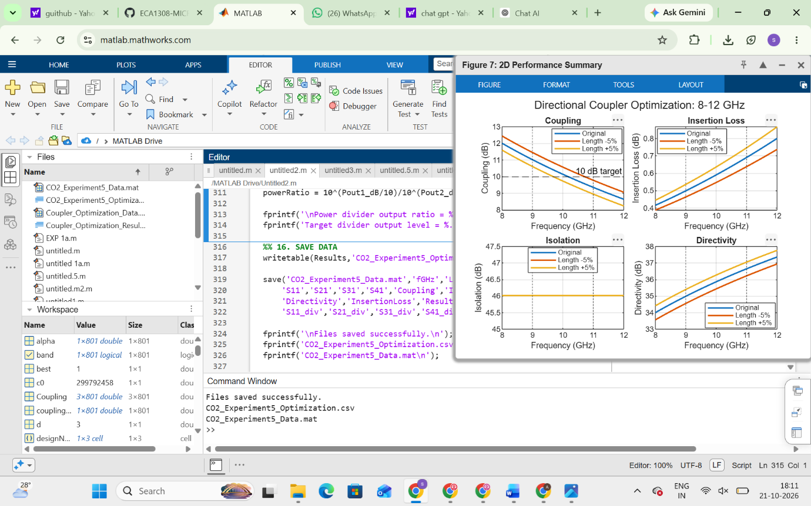
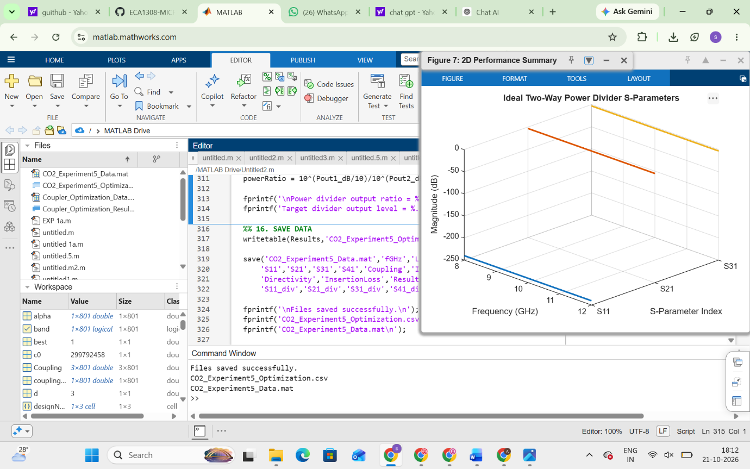
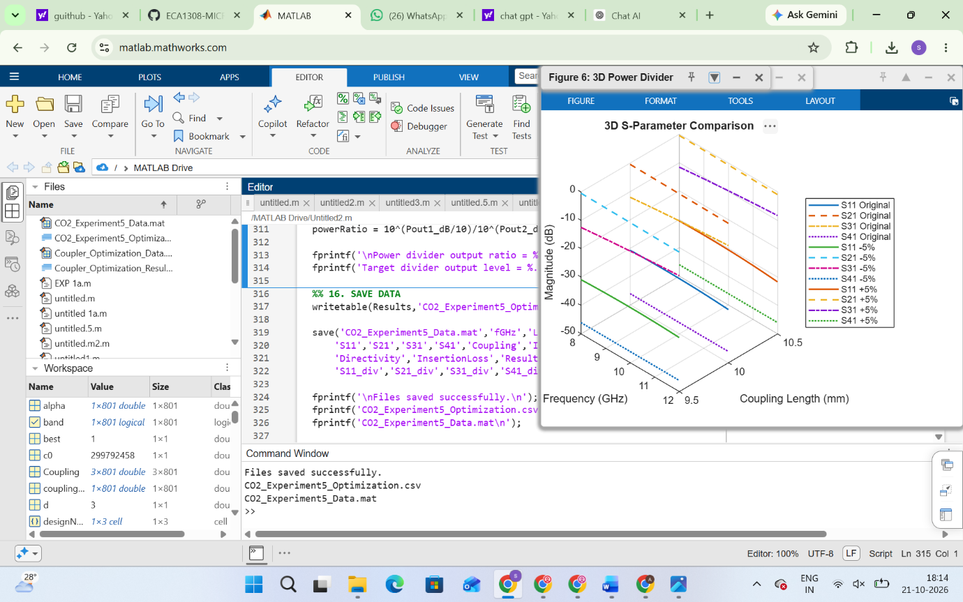
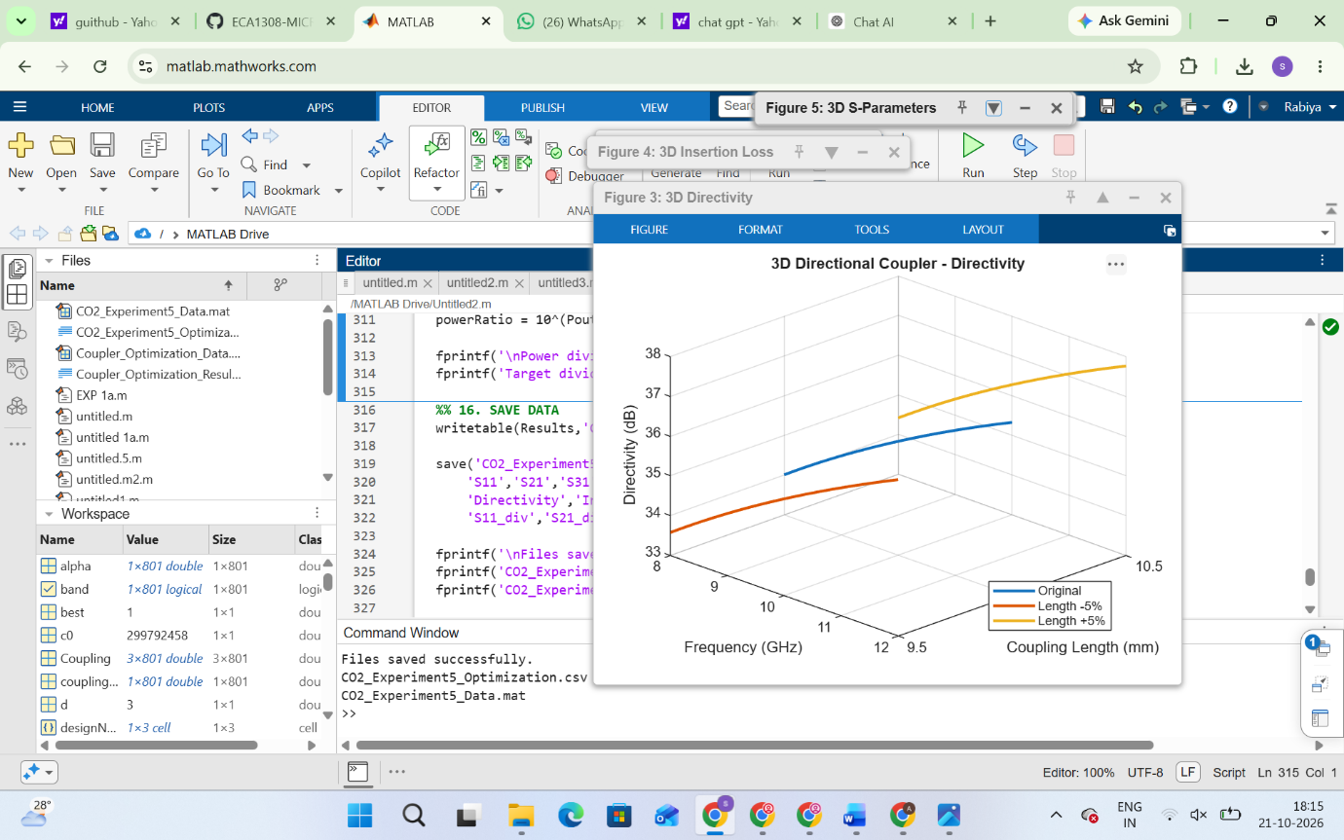

SIMULATION EXPERIMENT – 6
Simulation-Based Investigation of Microwave Semiconductor Devices and Frequency-Conversion Characteristics of a Microwave Mixer

Objectives of this Experiment:
1. To develop simulation models representing the operating characteristics of selected microwave semiconductor devices.
2. To analyze the electrical characteristics and frequency-dependent behavior of Gunn, Schottky or PIN diode-based microwave structures.
3. To simulate frequency conversion in a microwave mixer and identify the generated frequency components.
4. To evaluate conversion characteristics and identify suitable operating conditions for microwave applications.
Experimental Procedure
A. Mixer Frequency Conversion: Set fRF = 10 GHz, fLO = 9.5 GHz, PRF = −10 dBm and PLO = +7

dBm with a 50 Ω IF load. Obtain the output spectrum. Calculate the theoretical IF frequency |10−9.5| =
0.5 GHz and sum frequency 19.5 GHz. Identify the simulated components and calculate the percentage frequency deviation.

clc;
clear;
close all;

% EXPERIMENT 6A
% Microwave Mixer Frequency Conversion

fRF = 10; % RF frequency in GHz
fLO = 9.5; % LO frequency in GHz
PRF = -10; % RF power in dBm
PLO = 7; % LO power in dBm

% Calculate frequency components
fIF = abs(fRF-fLO);
fSUM = fRF+fLO;

fprintf('MICROWAVE MIXER FREQUENCY CONVERSION\n');
fprintf('RF Frequency = %.2f GHz\n',fRF);
fprintf('LO Frequency = %.2f GHz\n',fLO);
fprintf('IF Frequency = %.2f GHz\n',fIF);
fprintf('Sum Frequency = %.2f GHz\n',fSUM);

% Illustrative spectrum levels
freq = [fIF fLO fRF fSUM];
power = [-18 PLO PRF -25];

figure;
stem(freq,power,'filled','LineWidth',1.5);
grid on;
xlabel('Frequency (GHz)');
ylabel('Power (dBm)');
title('Microwave Mixer Frequency Spectrum');
legend('Frequency Components');

B.Conversion Loss: Using the same mixer, record the IF output power at 0.5 GHz. Calculate conversion loss CL = PRF − PIF and compare it with the expected passive-mixer range of approximately 6–10 dB. Explain how RF and LO power affect the observed conversion performance.

clc;
clear;
close all;

% EXPERIMENT 6B
% Conversion Loss of Microwave Mixer

PRF = -10; % RF input power in dBm
PLO = 7; % LO power in dBm
PIF = -18; % Assumed IF output power in dBm

% Conversion loss
CL = PRF-PIF;

fprintf('MICROWAVE MIXER CONVERSION LOSS\n');
fprintf('RF Input Power = %.2f dBm\n',PRF);
fprintf('LO Power = %.2f dBm\n',PLO);
fprintf('IF Output Power = %.2f dBm\n',PIF);
fprintf('Conversion Loss = %.2f dB\n',CL);

if CL >= 6 && CL <= 10
fprintf('Conversion loss is within the expected range.\n');
else
fprintf('Conversion loss is outside the expected range.\n');
end

% Plot conversion loss
figure;
bar(CL);
grid on;
ylabel('Conversion Loss (dB)');
title('Microwave Mixer Conversion Loss');
ylim([0 12]);

% Theoretical frequency deviation
fRF = 10;
fLO = 9.5;

fIF = abs(fRF-fLO);
fSUM = fRF+fLO;

fprintf('Theoretical IF Frequency = %.2f GHz\n',fIF);
fprintf('Theoretical Sum Frequency = %.2f GHz\n',fSUM);

